
University of Frontier Technology, Bangladesh
Department of Internet of Things and Robotics Engineering

Course Code | CC 483
Course Title | Cloud Computing

LAB REPORT
Lab 10: Cloud Infrastructure, High Availability & Observability on Azure
Network Isolation, Load Balancing & Cost Governance on Microsoft Azure

Submitted To
Farzana Akter
Assistant Professor
Department of Internet of Things and Robotics Engineering
University of Frontier Technology, Bangladesh
Submitted By
Sl | Class Roll | Name | Session
01 | 2201022 | Mst. Esat Jahan Akhi | 2022-2023

Date of Submission
August 6, 2026

Executive Summary
This lab report documents the architectural design, implementation, and operational validation of a secure, resilient, and monitored multi-tier cloud infrastructure on Microsoft Azure. The deployment fulfills three core enterprise system objectives:
- Network Security & Isolation (Task 1): Partitioning application and database infrastructure into isolated private subnets using Network Security Groups (NSG) to eliminate direct internet exposure to sensitive data.
- High Availability & Scalability (Task 2): Implementing an Azure Standard Load Balancer with active TCP Health Probes to distribute application workloads and provide seamless failover during single-instance outages.
- Observability & Cost Governance (Task 3): Enabling metric tracking via Azure Monitor, configuring threshold-based email notifications, and implementing monthly budget caps for cost efficiency.

Resource Group | Lab10-RG
Subscription | Azure for Students

Task 1: Secure Network & Private Database Deployment

1.1 Network Architecture
A customized Virtual Network (Lab10-VNet) was configured to isolate infrastructure components. The VNet topology is partitioned into two private subnets:
- AppSubnet (10.0.1.0/24): Hosts front-end/application virtual machines (App-VM and App-VM2).
- DBSubnet (10.0.2.0/24): Dedicated exclusively to backend database infrastructure (DB-VM).

1.2 Security Policy Configuration (NSG Rules)
Two Network Security Groups were established to enforce perimeter security controls:
- AppNSG: Inbound rules allow HTTP (Port 80) and HTTPS (Port 443) traffic from external networks to serve client web traffic.
- DBNSG: Inbound rules restricted database connections (Port 1433/3306) strictly to source IP addresses originating from AppSubnet (10.0.1.0/24). Direct inbound access from the public internet was explicitly set to Deny All.

1.3 Connectivity & Security Verification
Verification Scenario | Target Endpoint | Expected Behavior | Actual Result | Security Status
Public Internet Access to DB | DB-VM (10.0.1.5) | Connection Blocked / Timeout | Request timed out (100% packet loss) | PASSED (Secured)
App-to-DB Internal Access | DB-VM (10.0.1.5) | Connection Allowed | 64 bytes reply (0% packet loss) | PASSED (Connected)
Evidence of Perimeter Isolation & Routing Validation:
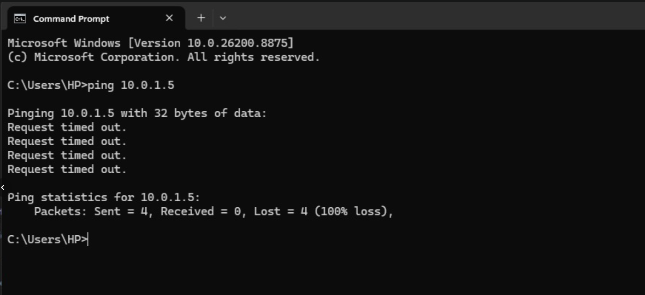
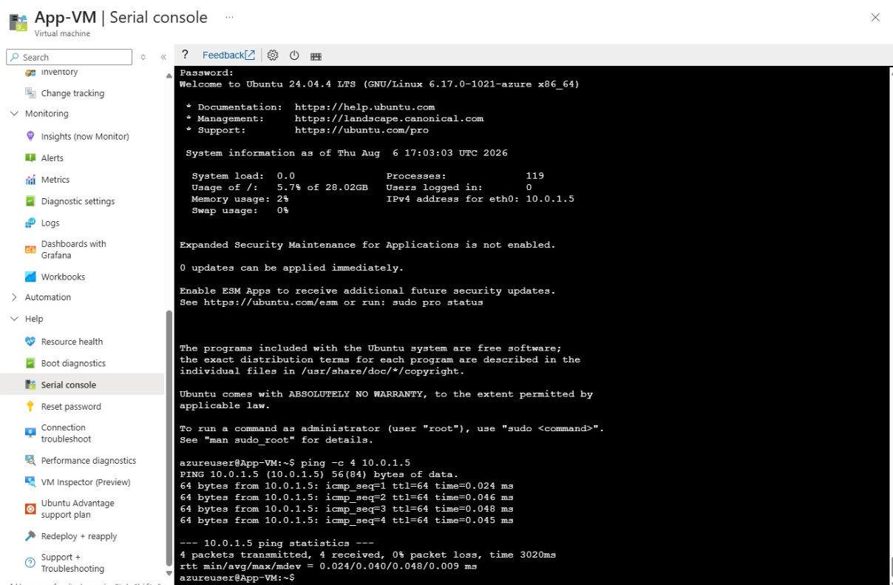

Task 2: Scalability & High Availability Configuration

2.1 Load Balancer Setup
An Azure Standard Load Balancer (Lab10-LB) was deployed to distribute incoming application traffic:
- Frontend IP Configuration: Bound to a Public IP (LB-Frontend-IP – 40.80.76.113).
- Backend Pool (App-Backend-Pool): Contains compute nodes App-VM (10.0.1.5) and App-VM2 (10.0.1.4).
- Health Probe (HTTP-Probe): Monitors backend host availability via TCP Port 80 at 5-second sampling intervals.
- Load Balancing Rule (HTTP-Rule): Evenly distributes port 80 incoming requests across active backend instances.
Configuration Evidence:
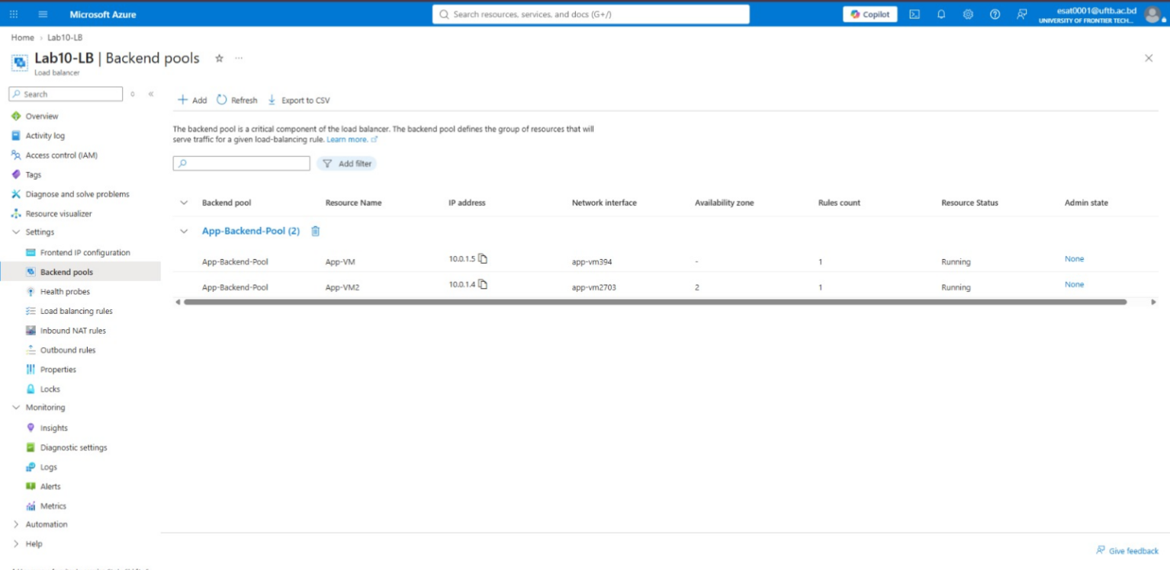
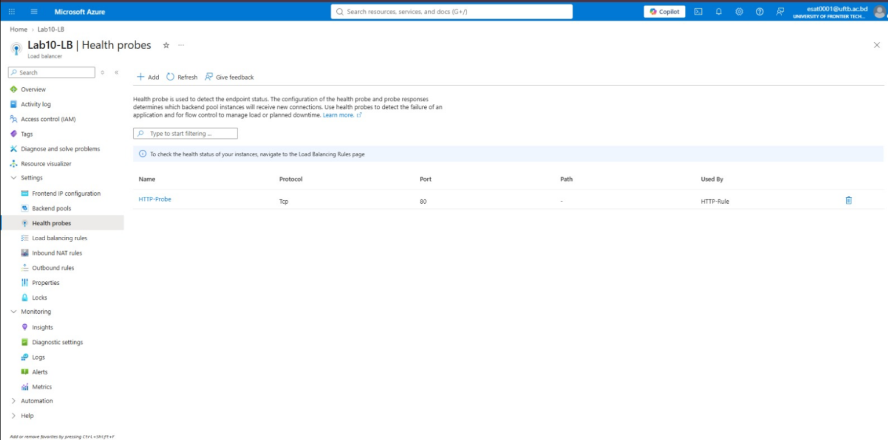

2.2 Failure Simulation & Failover Performance
To evaluate fault tolerance:
- App-VM2 was manually deallocated (stopped) via the Azure Portal to simulate a node outage.
- The HTTP-Probe detected health check failures and marked App-VM2 as unavailable.
- Traffic was dynamically rerouted entirely to the operational node (App-VM), maintaining uninterrupted application access.

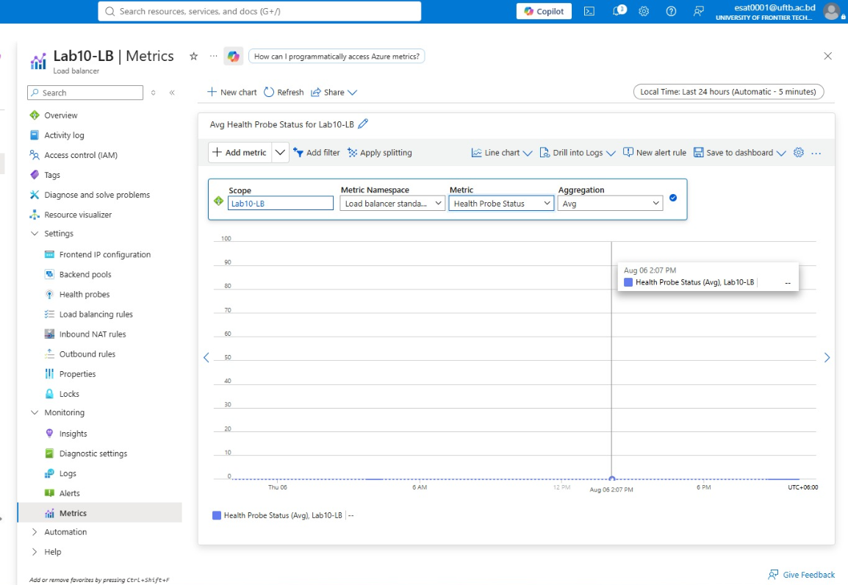
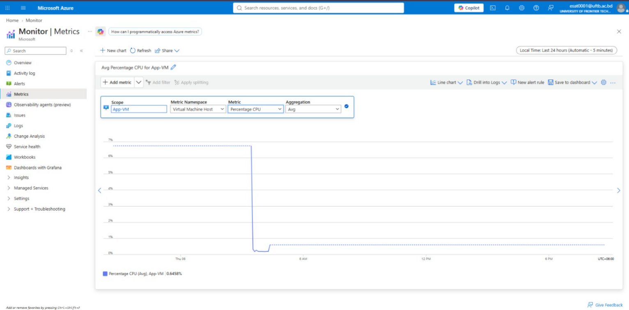
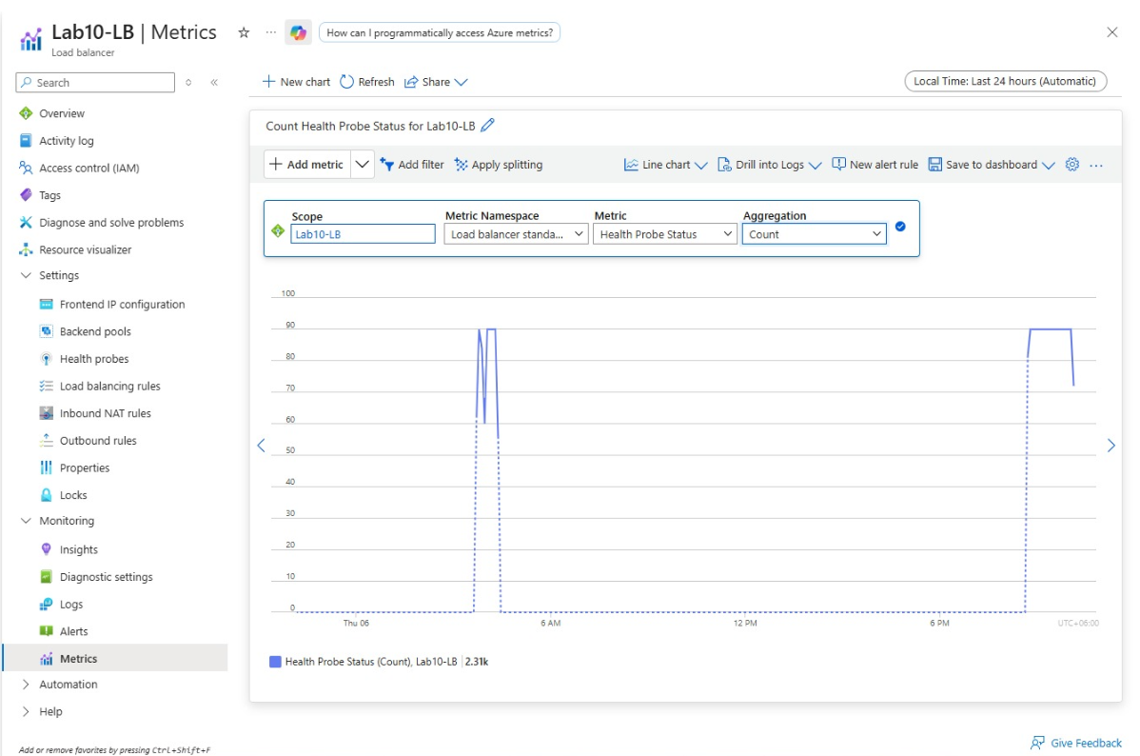

Task 3: Observability & Cost Governance

3.1 Metrics Monitoring & Metric Alert Rule
Azure Monitor was configured across all infrastructure components. An automated alert rule was set up to mitigate performance bottlenecks:
Target Resource | App-VM
Condition | Percentage CPU > 80%
Action Group | NotifyAdmin (Global scope, Display Name: NotifyAdmin)
Channel | Email notification dispatching alerts to administrators upon threshold breach.
Alert Setup & Delivery Evidence:
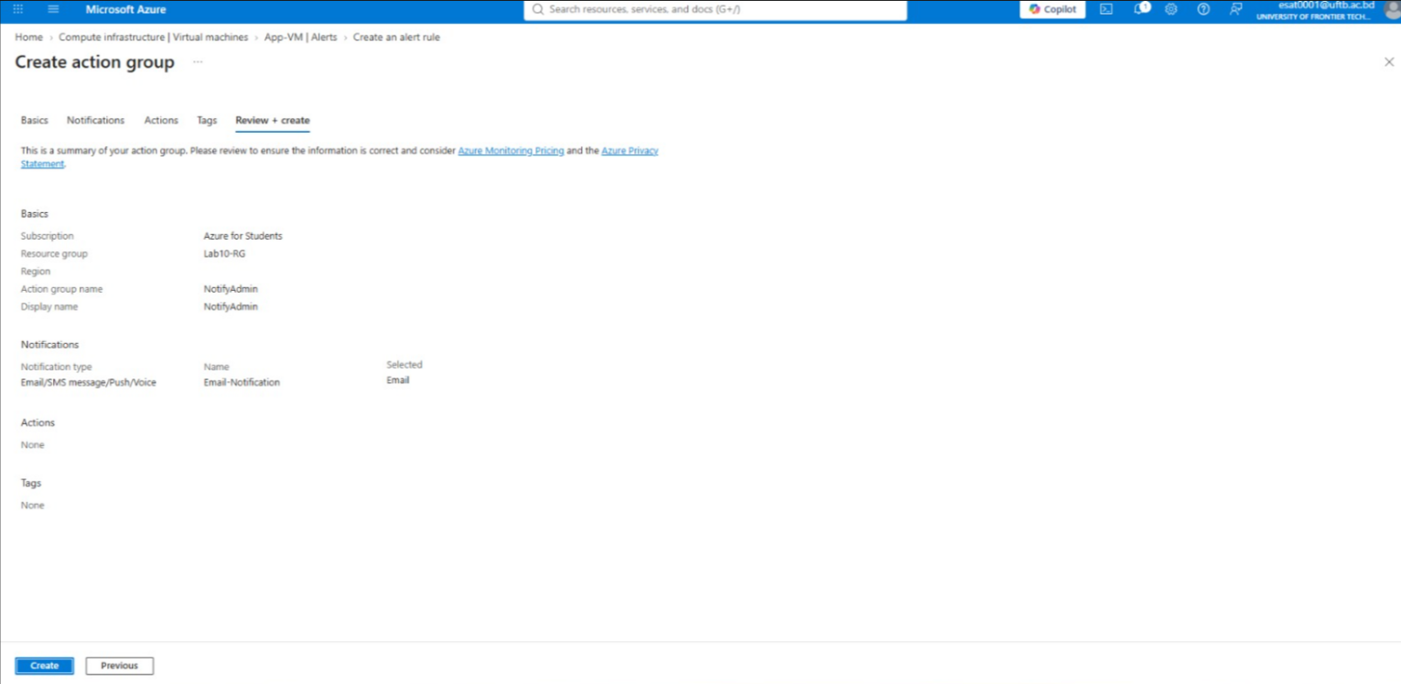

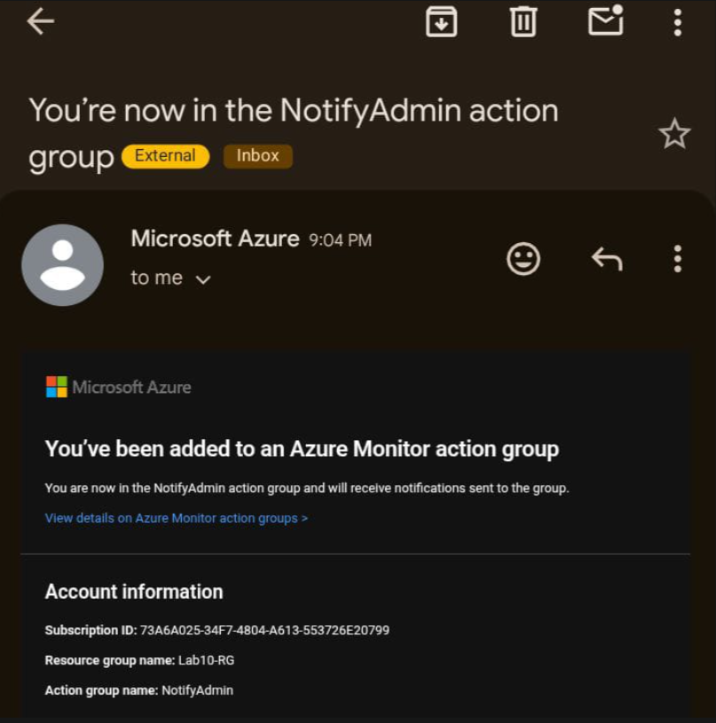

3.2 Cost Management & Monthly Budgeting
To manage resource usage and stay within credit allocations:
Scope | Lab10-RG / Subscription
Budget Name | Lab10-Monthly-Budget
Threshold Limit | $30.00 Monthly Cap (Alert triggered at 80% consumption)
Financial Tracking Analysis:
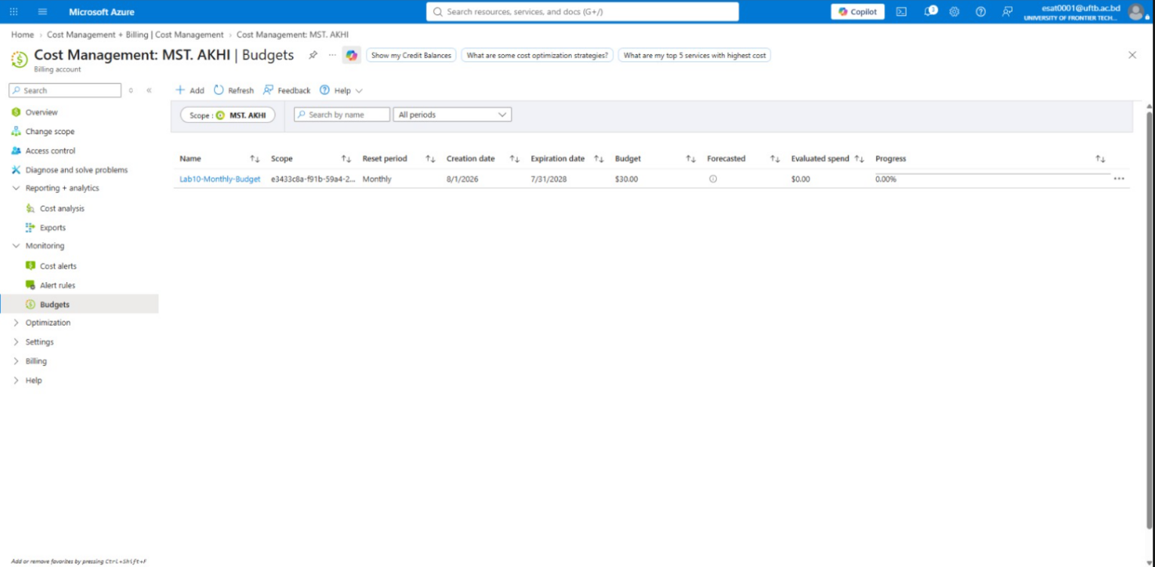

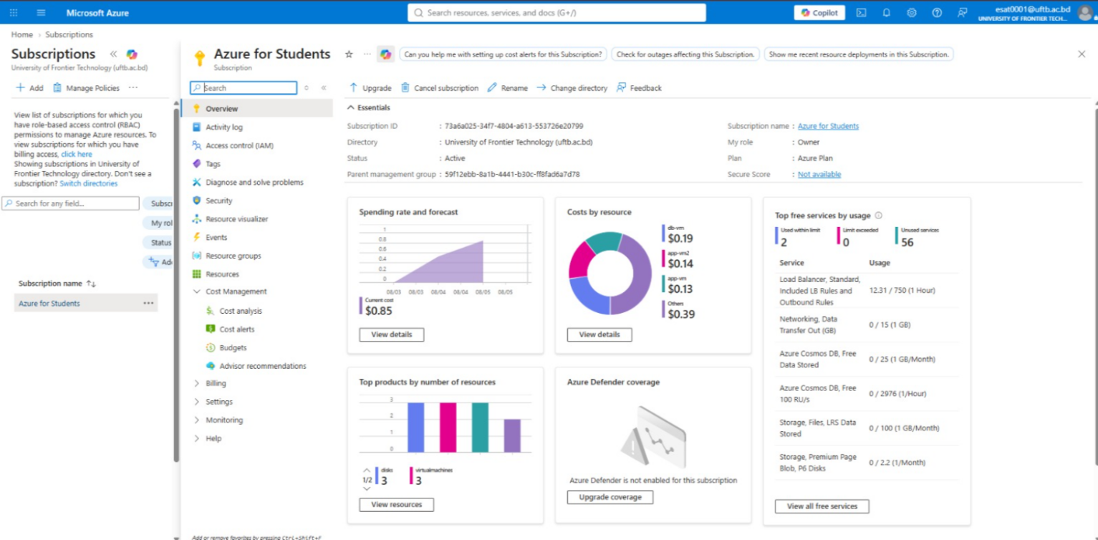

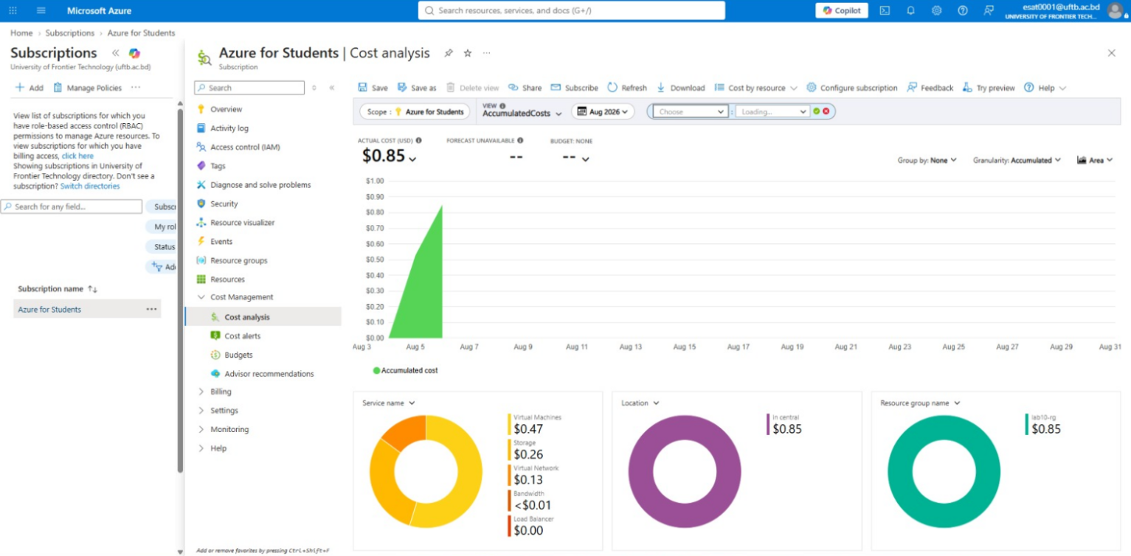

3.3 Analytical Answers & Technical Discussion

Question 1: Compare metrics before and after enabling load balancing. What changed and why?
Before Load Balancing
All incoming traffic was handled by a single Virtual Machine instance. Under high request rates or compute loads, CPU utilization and response latencies spiked on that single instance, creating a Single Point of Failure (SPOF).
After Load Balancing
Incoming requests are evenly partitioned across multiple compute instances (App-VM and App-VM2). Individual CPU usage per node dropped, network throughput was evenly distributed, and overall system fault tolerance improved. If one node experiences failure, the load balancer routes requests to surviving nodes with zero user impact.

Question 2: Identify which resources incur the highest cost and suggest optimization strategies.
Highest Cost Resources
- Virtual Machines (Compute – $0.47): Continuous running compute instances account for the primary portion of cloud spending.
- Storage Disks ($0.26): Provisioned OS and data disks incur persistent hourly storage costs regardless of compute state.
Optimization Strategies
- Auto-Scaling & Scheduled Shutdowns: Configure automated shutdown schedules or Azure Auto-Scaling during non-business hours to deallocate non-production compute resources.
- Instance Right-Sizing: Monitor average CPU utilization; migrate low-utilization nodes from general-purpose instances to burstable (B-Series) virtual machines.
- Azure Reserved Instances (RI): Utilize 1-year or 3-year reservation commitments for baseline production workloads to achieve cost savings up to 72% over standard pay-as-you-go rates.

Conclusion
The deployment successfully met all design requirements:
- Security: Subnet segregation and NSG rules successfully blocked public access to internal database endpoints while maintaining authorized application-tier access.
- Reliability: The Azure Load Balancer and health probe mechanisms enabled continuous application service during simulated virtual machine failures.
- Governance: Azure Monitor alerts and Cost Management budget thresholds established full operational transparency and cost governance.

